* Version control system is of two categories:

1. *Centralized*: Here, all team member connects to a central server to get the copy of the code and share changes with others. Example- **Subversion, Team Foundation Server**
2. *Distributed*: Here, every team member has a copy of the project with its history on his/her local machine. Example- **Git, Mercurial.**

* **Git GUI clients**: Most popular ones are **GitKraken** and **SourceTree.**

**Installing:** usual installation steps. Note, after installation we get **GitBash,** this is a command line tool. But it emulates Linux and UNIX environment. It is recommended to use this instead of the windows cmd.

**Configuration:** We can specify settings like name, email, default editor, line ending etc. There is three level of configuration as well.

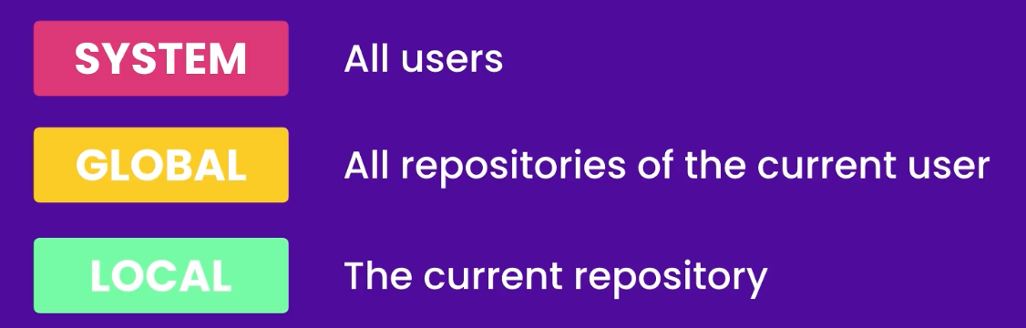

Example-

* git config –global user.name “Rafiqul Echo”
* git config –global user.email [echoece@gmail.com](mailto:echoece@gmail.com)
* git config –global core.editor “code --wait”
* git config –global -e
* git config –global core.autoclrf input

Notes:

1. on email we didn’t use double quotes cause its one word, on name its two words so we used double quotes.
2. Second Last command is for editing the config file with default file editor.
3. Last command is to deal with the issue of Windows (/r and /n) and Linux(/n) of new line character issue.